S D L C R E P O R T
SecAudit Software
Development Life
Cycle Report
Agile delivery, verification and quality evidence
Project: SecAudit - PyQt6 desktop security review tool
Author: Brendon
Date: 29 October 2026
Version: 1.0 - course submission

Cybersecurity course project October 2026

Table of Contents
1 Executive Summary
1 Executive Summary 1
2 Product Overview: What SecAudit Is and Is Not 2
2.1 Purpose and Positioning 2
2.2 Core Operating Rules 2
2.3 The Ten Screens 2
3 SDLC Model Selection and Approach 3
4 Requirements Engineering 4
5 System Design and Architecture 5
6 Implementation: The Agile Sprint History 5
6.1 Sprint 1 - Environment and Tool Registry 6
6.2 Sprint 2 - Installation Scripting 6
6.3 Sprint 3 - Scanner Integration Under Real Constraints 6
6.4 Sprint 4 - The Batch Review Engine 7
6.5 Sprint 5 - Report-Quality Hardening 7
6.6 Sprint 6 - Stability, Shutdown and Recovery 7
6.7 Sprint 7 - Scanner Warm-Up and Readiness 7
7 Agile Methodology in Practice 8
8 Testing and Verification 8
9 Deployment and Configuration 9
10 Maintenance: Known Gaps and the Next Roadmap 10
11 Risk Register 10
12 Conclusion 11

Note: This Table of Contents is generated via field codes. To ensure page number accuracy after editing, please right-click the TOC and select "Update Field."

1 Executive Summary
SecAudit is a native PyQt6 desktop application for bounded, read-only security review of explicitly selected files and folders on Windows. It combines local code-pattern checks, optional Semgrep and ClamAV integration in the full audit flow, fixed-argument lab tool adapters, file-trust evidence, and optional local or disclosed-cloud model assistance. The application never executes supplied files, never widens a confirmed scope, and never presents a missing or failed check as a clean result. This document rebuilds the earlier product overview as a Software Development Life Cycle (SDLC) report: it records how the product was planned, designed, built, tested, deployed and maintained, and it documents the Agile delivery practices that governed construction.
The report is written for a course assessor. It therefore favours verifiable statements over marketing language, and every quantitative claim traces back to the evaluation run of 28-29 October 2026 or to the technical documentation reproduced in the product brief. The current build was scored against two commercial endpoint products using ten weighted criteria: SecAudit reached 45 of 100 points, Microsoft Defender 73 and McAfee 54. On the review-and-audit lens that covers script analysis, evidence handling, honesty about limits, privacy and scope control, SecAudit scored 76 percent, ahead of both commercial products. The protection lens remains, by design, the domain of endpoint antivirus.
Three facts summarise the state of the build. First, the honesty mechanisms work: stale ClamAV signatures (94 hours old against a 72-hour limit) were reported as an unavailable check, and a failed model call was recorded as incomplete rather than clean. Second, the evidence chain verifies independently: SHA-256 hashes, the Ed25519 signature and the two-entry hash-chain ledger all reproduced under external checking. Third, the largest quality debt sits in finding content: snippets are generic, line numbers default to 1, and the built-in review produced zero findings on the same 26 files where supplier-intake heuristics raised 28 indicators. These gaps drive the maintenance backlog in section 10.
Table 1: Status snapshot of the evaluated build (report e63a697a, 28 October 2026)
Aspect | Status in the evaluated run
Static analysis | Semgrep 1.182.1 completed in 10.7 s over 15 paths using p/r2c-security-audit; the engine has no parser for Windows batch (.cmd) files.
Built-in review | 26 text files or ZIP members checked with 0 findings; supplier-intake heuristics raised 28 indicators (14 high, 14 medium) on the same files.
Malware signatures | ClamAV unavailable: signatures 94 hours old against the 72-hour limit. Reported as unavailable, never as clean.
Model review | Incomplete: the model reply could not be parsed (JSONDecodeError); the failure is visible in the report.
Evidence pack | report.json, findings.sarif and ledger.json hashes match the manifest; Ed25519 signature and both ledger entries verify.
Weighted score | 45/100 against Defender 73 and McAfee 54; review-and-audit lens 76% (Defender 47%, McAfee 38%).

2 Product Overview: What SecAudit Is and Is Not

2.1 Purpose and Positioning
SecAudit is a local-first desktop workbench for explicitly selected files and folders, with a separate, confirmed workflow for authorised lab targets. It wraps deterministic local checks and optional verified tools: source-pattern review, Semgrep, ClamAV, Windows Authenticode evidence and fixed-argument lab adapters where installed. Reports preserve scope, check status, coverage limits and partial failures, and can be exported as SARIF or as optionally signed, hash-chained evidence packs. A local journal flags interrupted work so the next launch can request scope re-confirmation rather than silently resuming.
The product deliberately occupies a position between informal checking and heavyweight security operations. It is a pre-production and pre-onboarding review aid: a team can inspect a supplier package, a prototype or a staff automation script, record what was checked and what was not, and document the decision. It is not a replacement for managed detection and response, a red-team engagement, secure-development governance or legal advice, and it does not claim that a completed scan proves a target safe.

2.2 Core Operating Rules
Six operating rules govern every workflow in the product. None of them was added as documentation decoration: each is enforced in code, exercised by tests, and phrased so an assessor can check the implementation against it. Table 2 states each rule and the mechanism that applies it.
Table 2: Core operating rules and how the build applies them
Rule | How SecAudit applies it
Explicit scope | The operator selects and confirms source paths before an audit; network adapters require a separately selected and confirmed authorised target.
Allow-list enforcement | The lab tool runner validates targets against lab_targets.txt; file scans never infer targets from filenames, findings or model requests.
Local deterministic execution | Fixed executable paths, argument arrays, bounded time and output, and no shell construction; models cannot select tools or commands.
Honest availability | Tool availability reflects real executable and version checks; unavailable, skipped and NOT RUN checks are never rendered as clean.
Read-only by default | Selected content is inspected, not executed or modified; quarantine is a separate confirmed action with hash verification and no-overwrite restore.
Untrusted evidence | Source, scanner output and model output are data; model explanations cannot erase scanner detections or authorise actions.

2.3 The Ten Screens
The interface is organised into ten native screens whose roles in the lifecycle are summarised in Table 3. The screens map one-to-one onto the product's workflows, so the table doubles as a functional inventory of the build being assessed.
Table 3: The ten desktop screens and their lifecycle role
Screen | Role in the product
New Audit | Selects up to 20 files or folders, sets objective and focus, and starts the confirmed read-only scan.
Dev: Batch Review | Local bounded analysis of up to 200 files with argument-aware behaviour, correlation and per-file coverage; Semgrep and ClamAV are labelled NOT RUN here.
File review | Single-file inspection: size, SHA-256 within 256 MiB, type hints and offline Authenticode status, without execution.
Network | Local interface snapshot and explicitly confirmed diagnostics; tool runner is restricted to allow-listed lab targets.
Run Monitor | Live stage, coverage, findings and scanner readiness chips fed by background warm-up probes.
Reports | Findings, check coverage and details; SARIF export, annotated Markdown copy, evidence pack and confirmed quarantine or restore.
Assistant | Local or disclosed-cloud chat over selected reports and bounded imports; sources and routing shown in a details panel.
Skills | Built-in review profiles plus up to 30 locally stored custom workflows; guidance only, never new scanner rules.
Settings | Exclusive provider selection, local model management, ClamAV signature updates, scanner warm-up probes and offline mode.
About | Routing acknowledgements and the statement that the wrapper does not invoke the upstream autonomous Strix engine.
Two statements bound everything above. SecAudit is not permission to scan public websites, unrelated networks or third-party systems, and it is not an autonomous agent: a model cannot invent commands, widen scope or erase scanner evidence. These boundaries are design decisions rather than disclaimers, and later sections show how each one was implemented, tested and verified during the build.

3 SDLC Model Selection and Approach
The project uses an iterative-incremental lifecycle with Agile construction inside a gated phase structure. A pure waterfall was rejected early: the first integration sessions showed that requirements were still being discovered while code was being written. Tool installation failed in ways that changed the plan (semgrep could not install on the machine's primary Python 3.15 interpreter, and the sqlmap executable landed in a user-scope Scripts directory rather than the expected system path), and the first real batch report exposed report-quality defects that no amount of upfront analysis would have predicted. Waiting for a complete, frozen requirement set would have meant designing against fiction.
Pure Scrum without phase gates was rejected for the opposite reason: a security tool needs auditable milestones. The adopted model keeps six classic SDLC phases as gates with defined artefacts, and runs construction as a sequence of seven sprints whose backlogs come directly from test-run defects. Each gate is a release review against the product's own honesty rules: a phase is not done while any check can silently render as clean, and documentation must be updated in the same sprint as the behaviour it describes. Figure 1 shows the phase flow; the feedback arrows are not decorative, because both the defect backlog and the maintenance roadmap enter the cycle through them.
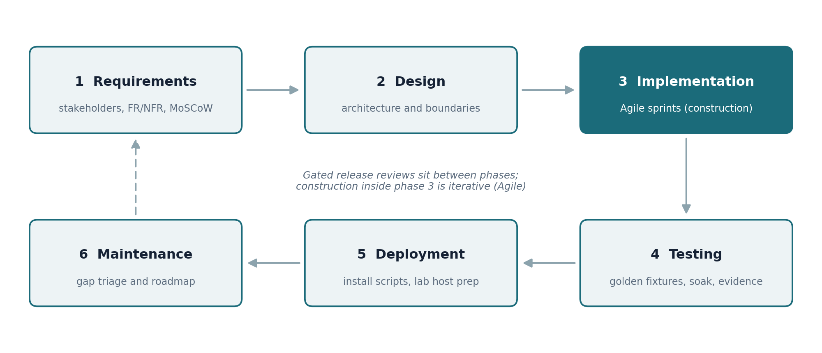
Figure 1: SecAudit SDLC phase flow with gated reviews and feedback into the backlog
Table 4 maps the classic phase names onto what actually happened in this build. The phase gates are release reviews rather than paperwork: a gate passes only when the coverage matrix is honest, the documentation matches the behaviour, and the increment is verifiable from its own artefacts.
Table 4: Classic SDLC phases mapped to SecAudit activities and artefacts
Phase | SecAudit activity | Primary artefacts
Requirements | Stakeholder needs, functional and non-functional requirements, MoSCoW triage | Requirements tables (section 4)
Design | Architecture, security boundaries, process containment model | Component map (section 5)
Implementation | Seven Agile sprints: registry, installers, scanners, engine, quality, stability, warm-up | Sprint history (section 6)
Testing | Golden fixtures, exit-code matrices, soak and cancellation tests, pack verification | Verification tables (section 8)
Deployment | Installation scripts, Defender allowlisting scope, lab host preparation | Deployment map (section 9)
Maintenance | Gap triage, signature freshness policy, roadmap phases | Backlog and roadmap (section 10)

4 Requirements Engineering
Requirements engineering ran as a living activity rather than a single up-front document. The initial requirement set came from the course brief and the intended user groups: small-business reviewers who need a first look at an untrusted package, developers who want static evidence about selected source, analysts who run repeatable lab probes, and students learning why authorisation and evidence matter. As sprints progressed, defects discovered in real runs flowed back into the requirement tables, and the MoSCoW priorities below reflect the state after the report-quality hardening sprint, not the original sketch.
Two requirements shape everything else and are therefore non-negotiable. The first is explicit scope: no scan ever starts without user selection and confirmation, and the scanner never infers a broader target. The second is honest availability: every check must report its real status, because a missing tool or an expired signature database says nothing about the target and must never be confused with a clean result. Both requirements exist because the product's core value is trustworthy evidence rather than detection volume.
Table 5 lists the selected functional requirements with their post-hardening MoSCoW priorities. The priorities record what the build treats as non-negotiable after five sprints of contact with real defects, not the original sketch.
Table 5: Selected functional requirements (MoSCoW)
ID | Requirement | Priority
FR1 | Explicit scope selection and confirmation before any scan; no implicit default target | Must
FR2 | Read-only bounded intake: at most 200 files, 4 MiB per file, 64 MiB total, 64 KiB chunked reads | Must
FR3 | Local pattern rules with argument-aware command parsing for supported script families | Must
FR4 | Stable finding contract: correlated rules, line range, behaviour, redacted excerpt, detection and threat certainty, MITRE mapping, nullable validated CWE | Must
FR5 | Honest coverage matrix: every check reports ran, unavailable, skipped or NOT RUN | Must
FR6 | Optional Semgrep in the full audit flow, verified by version check and a bundled fixture scan | Should
FR7 | Optional ClamAV with a signature freshness policy and confirmed, hash-verified quarantine and restore | Should
FR8 | Signed evidence pack: redacted report, SARIF 2.1.0, SHA-256 manifest, Ed25519-signed hash-chain ledger | Should
FR9 | Exclusive Local (Ollama) or Cloud (OpenRouter) routing with disclosure confirmation before cloud evidence | Must
FR10 | App-level offline mode blocking cloud requests, public search, remote rule packs, model pulls and signature downloads | Should
Table 6 records the non-functional requirements that later sprints measured themselves against. Each target is deliberately phrased as an observable behaviour rather than an adjective, so the acceptance check is binary.
Table 6: Selected non-functional requirements
ID | Requirement | Target
NFR1 | UI responsiveness under load | One-thread worker pool, coalesced progress, cancellation checked between files
NFR2 | Predictable shutdown | Graceful close stops child processes within about 3 s; kill-on-close Job Object covers the tree; journal enables recovery after hard termination
NFR3 | Deterministic process execution | Argument arrays only, no shell, bounded timeouts and output caps, CREATE_NO_WINDOW
NFR4 | Local-first privacy | Local scanning and local models by default; cloud sends only after disclosure confirmation; no fallback to local on cloud failure
NFR5 | Bounded retention | At most 100 saved reports and 500 memory records; learned memory excludes full source files and raw excerpts

5 System Design and Architecture
The application is a native Qt widget program: the desktop shell is Python with PyQt6, it does not embed a web engine, and there is no JavaScript bridge between the interface and the scan pipeline. This decision followed directly from the threat model. Scan targets, scanner output and model replies are all untrusted input, and a web-based interface would add an entire class of injection surface for zero product benefit. Keeping the interface native keeps the trust boundary small and reviewable.
The pipeline is offline-first and deterministic-by-default. Local pattern checks run first; verified external tools such as Semgrep and ClamAV run only when their executables and, for ClamAV, sufficiently recent signatures are present; the model layer explains evidence only after deterministic checks have produced it. Scanners produce evidence, models explain evidence, and the explanation layer can never overwrite a scanner finding. Provider routing is exclusive: a session is either Local (Ollama on loopback) or Cloud (OpenRouter), and a cloud failure never silently falls back to a local model.
Process containment is the architectural signature of the build. Every subprocess launch goes through one shared helper that enforces argument arrays, rejects shell invocation, closes stdin, captures output instead of opening a terminal window, applies bounded timeouts, and holds Windows child processes in a kill-on-close Job Object. Cancellation is checked between files, and a local recovery journal records selected paths and completion state so that even a Task-Manager hard kill is recoverable on the next launch. The component table below shows where each responsibility lives.
Table 7: Core components and responsibilities
Component | Responsibility
ui/main_window.py | Native PyQt6 interface: scope selection, progress, assistant and results
ui/dev_window.py | Dev Toolkit screens and Batch Review rendering on a bounded worker pool
dev_toolkit/engine.py | Read-only bounded static analysis, finding normalisation, behaviour correlation, file-level coverage
dev_toolkit/intake.py | Supported-file discovery, chunked bounded reads, streaming SHA-256
dev_toolkit/models.py | Finding contract, analysis limits, coverage and result serialisation
core/strix_engine.py | Scoped pattern checks, Semgrep and ClamAV adapter coordination, SARIF export
core/semgrep_scanner.py | Bounded Semgrep CLI invocation and JSON-to-finding and coverage mapping
core/clamav_scanner.py | Bounded one-shot and loopback daemon scans, coverage parsing, daemon lifecycle
core/semgrep_warmup.py, clamav_warmup.py | Background version and functional probes; persisted scanner readiness
core/processes.py | Argument-array launching, output caps, cancellation, Job Object containment
core/evidence_pack.py | Passphrase-protected Ed25519 key, signed report bundles, hash-chain ledger
core/learning_memory.py | Bounded report archive, redacted scan memory, assistant report context
Security boundaries complete the design picture. Only explicitly selected and confirmed paths are ever scanned. Archives are inspected without extraction, with traversal members and excessive expansion reported as findings. Network-capable lab adapters validate targets against lab_targets.txt before execution and log rejected out-of-scope attempts. The upstream Strix checkout that ships alongside the wrapper is never invoked for folder scans, and the About screen says so explicitly, because naming the real engine matters to anyone auditing the evidence chain.

6 Implementation: The Agile Sprint History
Construction ran as seven sprints between the initial environment survey and the scanner warm-up work, each producing a runnable increment plus an honest status note. The sprints were not calendar-boxed ceremonies: a sprint ended when its goal was verifiable, and its backlog came from the defects the previous increment exposed. Table 8 summarises the sequence; the subsections record what each sprint actually did and what it taught, because the lessons changed later decisions more than the code did.
Table 8: Sprint summary
Sprint | Focus | Key outcome | Lesson carried forward
S1 | Environment and tool registry | Registry reflects verified executables and versions only | Trust version-flag output, not install presence
S2 | Installation scripting | Repeatable installer for six CLI tools and ClamAV | Verify every path; Windows installs fail sideways
S3 | Scanner integration | Semgrep working on side-by-side Python 3.12 | Interpreter conflicts and AV interference are first-class risks
S4 | Batch Review engine | Finding contract, correlation and validated CWE mapping | Narrow CWE emission preserves analyst trust
S5 | Report-quality hardening | Regression tests built from a real defective report | Test against the app's own worst output
S6 | Stability and shutdown | Job Object containment, journal recovery, bounded shutdown | Design the recovery path; hard kills cannot be intercepted
S7 | Scanner warm-up | Readiness probes and daemon mode with honest status chips | Readiness is a measured state, not an assumption

6.1 Sprint 1 - Environment and Tool Registry
The first sprint established the rule that the tool registry reports only what it can prove. Every entry in the registry JSON carries the tool name, an availability flag, the executable path and a version string, and availability flips to true only after the executable answers a version request that matches the expected output shape. The sprint also produced the project's first real disambiguation lesson: the registry initially confused the Python httpx package with ProjectDiscovery's httpx reconnaissance tool, because both answer on the command line. The resolution rule inspects the response text and only accepts the ProjectDiscovery tool when its output carries the Current Version marker. The lesson generalised into a design principle for every later integration: verification means parsing the tool's actual version output, never trusting the fact that a file exists.

6.2 Sprint 2 - Installation Scripting
The second sprint turned manual installation into a repeatable PowerShell script that pulls the latest release archives for ffuf, httpx, nuclei, subfinder, katana and naabu into C:\Tools and installs ClamAV through its MSI. Two Windows-specific failures defined the sprint. The ClamAV download initially saved without a file extension, which made Start-Process refuse to launch it; the fix was to append the .msi extension explicitly and invoke the installer through msiexec with a quiet flag. The sqlmap installer, meanwhile, performed a user-scope pip install and placed the executable in the per-user Python 3.15 Scripts directory rather than any system path, so the script learned to search the per-user location as well. The sprint's outcome was less the script itself than the habit of ending every installation with a verification loop that re-runs the registry checks from Sprint 1.

6.3 Sprint 3 - Scanner Integration Under Real Constraints
The third sprint integrated the two signature scanners and hit the build's hardest environment problem: semgrep publishes no wheels for the machine's Python 3.15 interpreter, and pip backtracked through dependency builds until failing inside a compiler-dependent package. Forcing the issue was not an option, so the resolution installed Python 3.12 side by side and targets the interpreter explicitly with the py launcher. The second problem was Defender quarantining scanner engine binaries, which made a correctly installed tool report itself broken; scoped exclusions for the tool directories plus file unblocking resolved it, and the exclusions were kept deliberately narrow so that scanned targets never receive blanket exemptions. The sprint ended with both scanners answering version checks and the registry distinguishing verified tools from merely present ones.

6.4 Sprint 4 - The Batch Review Engine
The fourth sprint built the deterministic core of Batch Review: bounded intake with streaming hashing, YAML rule packs, argument-aware command parsing for supported command families, and the finding contract that later sprints depend on. The contract separates detection certainty from threat certainty so that a confident pattern match never implies malicious intent, and it emits CWE identifiers only for validated behaviour classes drawn from a short whitelist. Behaviour correlation merges detections that share a file, line range and behaviour class, keeps unrelated same-line behaviours separate, and assigns the merged finding the maximum severity of its inputs. The design choice that defined the sprint was restraint: a hardcoded IP address or a scheduled-task query earns no CWE at all, because a wrong label is worse than an honest gap.

6.5 Sprint 5 - Report-Quality Hardening
The fifth sprint began with an uncomfortable artefact: a real batch report in which the same scheduled-task behaviour appeared as two duplicate findings, a hardcoded IP carried a wrong CWE, evidence excerpts were a single token at line 1, and three of four files showed no coverage information at all. That report became the sprint's regression corpus. Failing tests were written against its exact defects, then parsers were upgraded to capture parsed arguments and redacted line-numbered excerpts, correlation was taught to merge the duplicates, and the coverage matrix was extended so every file reports which rules and scanners considered it. The sprint's lesson is now standard practice on the project: regression tests come from the application's own defective output, because idealised fixtures encode only the failures the author already imagined.

6.6 Sprint 6 - Stability, Shutdown and Recovery
The sixth sprint addressed failure behaviour under load. The scan worker pool runs on a single thread with progress coalesced by file batch, so a burst of findings cannot flood the interface; cancellation is checked between files, so a cancelled audit stops promptly without corrupting state. An global exception hook converts unhandled errors into a crash dialog instead of a silent death, and every Windows child process is placed in a kill-on-close Job Object so that terminating the application cannot leave orphaned scanners behind. Because a Task-Manager hard kill cannot be intercepted by any user-mode handler, the recovery journal is the designed response: the next launch detects the interrupted scan and asks for scope re-confirmation instead of resuming blindly. The sprint's acceptance target was a graceful close that terminates children within roughly three seconds.

6.7 Sprint 7 - Scanner Warm-Up and Readiness
The seventh sprint made scanner readiness visible instead of assumed. Semgrep is verified in two stages, a version check followed by a real scan of a bundled fixture, because a version response alone cannot detect an engine whose binaries Defender has quarantined. ClamAV gained a loopback-only daemon mode that loads the signature database once per session, with a one-shot fallback and the fallback reason recorded in the report; its engine probe uses a custom hash-signature fixture rather than the EICAR test string so that Defender cannot consume the test artefact. Both scanners expose persisted readiness chips on the Run Monitor, fed by background probes that never block the interface. The sprint closed the loop with the honesty rule: readiness, staleness and fallback are reported states, and none of them is ever rendered as a clean result.

7 Agile Methodology in Practice
The project did not adopt Agile ceremonially; it adopted the practices that a single-developer security tool can actually sustain, and Figure 2 shows the cycle as it really operated. The backlog was defect-driven: every evaluation run produced a gap list, and the gap list became the next sprint's work items rather than a document of shame. Sprint planning meant choosing one goal and writing down, in advance, what evidence would count as done. The sprint review artefact was not a slide deck but the application's own generated report plus its signed evidence pack, which is why report quality and process quality improved together.
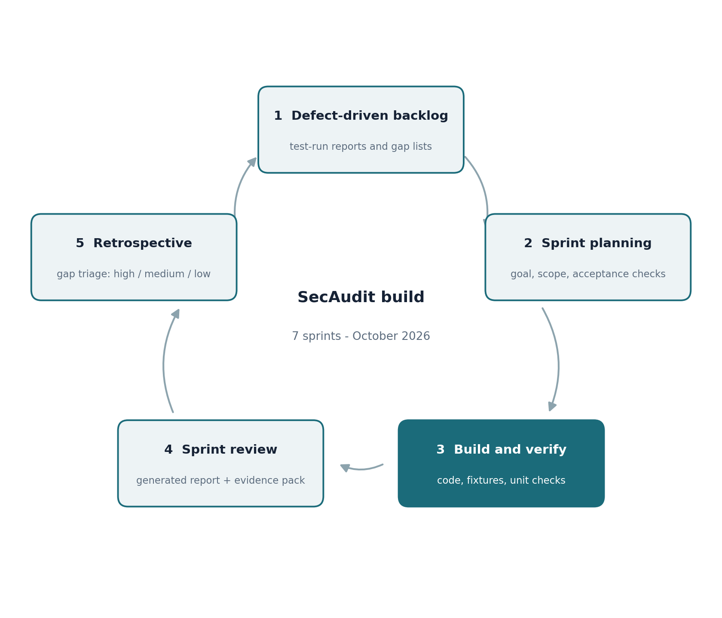
Figure 2: The Agile cycle as practiced in the SecAudit build
The retrospective practice deserves specific mention because it left a paper trail. After each run, defects were triaged into high, medium and low priorities, and the high-priority items were promoted into the next sprint. The nine documented gaps in section 10 are the surviving output of those retrospectives, with their priorities intact. The Definition of Done hardened the same way: a sprint was not complete while any check could silently render as clean, while any skipped file lacked a stated reason, or while documentation described behaviour the build no longer had. Table 9 maps each practice to its application and evidence.
Table 9: Agile practices as actually applied in the SecAudit build
Practice | How SecAudit applied it | Evidence
Backlog | Test-run defects and gap lists became the work items for the next sprint | Nine-gap backlog in section 10
Sprint planning | One goal per sprint with acceptance checks agreed up front | Sprint summaries in section 6
Build and verify | Each increment runnable, with fixture tests and unit checks alongside code | Golden fixture and exit-code tests
Sprint review | Review against the app's own generated report and signed evidence pack | Report e63a697a and pack verification
Retrospective | Defect triage into high, medium and low priorities feeding the backlog | Gap priorities in section 10
Definition of Done | No silent clean results; every skip reasoned; documentation current | Honest coverage matrix in reports
Roles stayed honest to the project's scale. The developer and the operator were the same person, but the review roles were kept distinct on purpose: findings were triaged as if by a separate analyst, and the evaluation against commercial products was performed from generated artefacts rather than from memory of what the code was supposed to do. Keeping those hats separate is what allowed the scorecard in section 8 to criticise the build it measured, and it is the practice most worth keeping as the project grows beyond one developer.

8 Testing and Verification
Testing follows the product's own philosophy: verify what actually ran, and never confuse a test that did not execute with a pass. The strategy has four layers. Golden fixture tests feed known files through the pipeline and assert the exact findings, redactions and coverage states. Exit-code matrices drive each external tool through success, detection, partial-error and garbage output to prove that the coverage matrix responds correctly to every outcome. Soak and cancellation tests run large batches with mid-scan cancellation and assert bounded shutdown with no surviving child processes. Finally, the evidence pack is verified independently: the exported artefacts were re-checked outside the application with the results in Table 10.
Table 10: Independent verification of the signed evidence pack
Check | Result | Note
SHA-256 and size of report, SARIF and ledger match the manifest | Pass | All three payload files
Ed25519 signature verifies over the manifest bytes | Pass | Verified against the embedded public key
Public-key fingerprint equals the manifest signing key id | Pass | Fingerprint 3510263a40f30799409530f9
Ledger chain: two entries, previous hashes match, chain head equals last entry | Pass | Sequence 1 is an earlier report
Ledger entry signatures verify over the canonical entry body | Pass | Both entries
Independent recomputation of entryHash | Not reproduced | Link chain and signatures verify; the hash derivation must be documented so third parties can repeat it
Trust limits | Info | Self-signed local key, no timestamp authority, no compliance mapping; fingerprints must be compared out of band
The comparative scorecard scored ten weighted criteria against the two commercial products visible in the evaluation screenshots. It is an engineering assessment of one run, not a benchmark: Defender scanned the folder by command line, McAfee scanned 18 items of unstated scope, and SecAudit considered 36 files in the same folder. The scores that follow are quoted from that assessment, and the reading matters more than the total: the two commercial products disagreed with each other on the sample, which is itself a reminder that one engine reporting no threats is weak evidence.
Table 11: Scorecard against commercial products (weight x score / 5, total of 100)
Criterion (weight) | SecAudit | Defender | McAfee
Known-malware detection (20) | 1 | 5 | 3
Behaviour and unknown-threat detection (15) | 1 | 4 | 3
Real-time protection (10) | 0 | 5 | 4
Script and source analysis, explainability (15) | 3 | 1 | 1
Evidence, reporting and audit trail (10) | 4 | 3 | 2
Honesty about coverage and limits (10) | 4 | 3 | 2
Privacy and local-first operation (5) | 4 | 3 | 3
Response and remediation (5) | 2 | 5 | 4
Scope control and safe-by-design (5) | 5 | 3 | 3
Speed and footprint (5) | 2 | 5 | 4
Weighted total (of 100) | 45 | 73 | 54
Protection lens (55%) | 20% | 95% | 67%
Review and audit lens (45%) | 76% | 47% | 38%
The scorecard's diagnostic value exceeded its ranking value. It located the four improvements with the highest score leverage: real snippets and line numbers together with Batch Review rules inside the full audit (worth about three points), automated ClamAV signature freshness (about four), a sandboxed behaviour check for selected scripts (about three), and skip-reason completeness plus correct SARIF tool naming (about four). Landing all four would move the weighted total from about 45 to about 59, above McAfee's 54 and still below Defender's 73, which is the expected shape for a review tool measured next to an endpoint product.

9 Deployment and Configuration
Deployment is scripted rather than documented-by-legend. Two PowerShell scripts carry the environment from a clean Windows host to a working toolchain: one installs the six ProjectDiscovery tools and ClamAV with a verification loop at the end, and the other prepares an authorised lab host with scoped Defender and firewall exceptions for the tool directories. The lab host script also carries the interpreter fix from Sprint 3, installing semgrep through the side-by-side Python 3.12 rather than the default interpreter. Both scripts encode the same honesty rule as the application: a step is not complete because it did not throw an error, but because the verification loop confirms the expected version output.
The deployment boundary is deliberately explicit about what allowlisting means. Defender exclusions cover the tool executables, engine payloads and cache directories, never the directories that will be scanned, and the documentation states that exclusions reduce interference rather than confer trust. Administrator mode starts only through a visible UAC prompt and grants no blanket elevation. App-level offline mode blocks cloud requests, public search, remote rule-pack resolution, model pulls and signature downloads, and it says plainly that it is an application policy, not an operating-system firewall or proof that no traffic left the machine. Table 12 summarises the configuration surface.
Table 12: Deployment and configuration areas
Area | Approach | Stated boundary
Installation | Scripted install with end-of-script verification loop | Availability requires verified version output, not file presence
Defender allowlisting | Scoped exclusions for tool executables, engines and caches on the lab host | Never excludes scanned target directories; not a trust statement
Offline mode | App-level policy persisted in local settings | Not an OS firewall; cannot prove no network egress
Administrator mode | Started only via a visible UAC prompt | Not a blanket permission grant; does not bypass UAC
Signature updates | App-managed ClamAV database updated from Settings | Stale signatures make the check unavailable, never clean
Lab targets | lab_targets.txt allow-list with rejection logging | Out-of-scope targets are refused and logged, never scanned

10 Maintenance: Known Gaps and the Next Roadmap
Maintenance runs on the same defect-driven loop that fed the sprints. The nine gaps below were identified by the 29 October 2026 evaluation against generated files, triaged by priority, and each carries a concrete remediation. They are recorded here as the live backlog rather than as footnotes, because the scorecard's improvement estimate depends on exactly these items closing.
Table 13: Documented gaps and remediation plan
# | Gap | Priority | Remediation
1 | Findings carry no real code evidence: snippets repeat the rule description and line numbers default to 1 | High | Capture the redacted matching line and its true line number; never store secret values
2 | Built-in review returned 0 findings where the automation module raised 28 on the same 26 files | High | Run the Batch Review rule engine inside the full audit so scripts get the same rules
3 | Documentation files flagged as automation with network behaviour | Medium | Skip or downgrade non-executable documents to informational
4 | Model reply failed to parse (JSONDecodeError), losing model review | Medium | Use structured output with a JSON schema and one repair retry; keep the raw reply in the log
5 | SARIF names the tool Strix although findings come from SecAudit checks | Medium | Report the tool as SecAudit with its version; name Strix only when its engine ran
6 | Skipped files unexplained: 8 skipped, 2 reasons recorded | Medium | Give every skipped file an explicit reason
7 | Path redaction breaks on spaces, producing partial paths | Low | Redact the full path prefix including spaces
8 | ClamAV freshness unclear: 72-hour rule versus a database build over a year old | Medium | Confirm what the freshness rule measures; verify FreshClam is actually fetching the daily database
9 | No ATT&CK mapping on the affected findings | Low | Add MITRE techniques where behaviour is validated, as Batch Review already does
The roadmap extends the same loop into the next development cycle. The trust-and-provenance phase adds checksum comparison against published values, OSV synchronisation and SBOM export so that the evidence pack can speak about dependencies as well as files. The isolation phase introduces WSL2 and Windows Sandbox execution paths behind the existing mediation layer, which is what unlocks the behaviour-detection points identified in the scorecard. The model-service phase consolidates the assistant's classifier, decoder ladder and escalation rules behind one bounded service interface. Each phase enters through the same gate as the last seven sprints: a defined artefact, verified behaviour and documentation updated in the same change.
Success criteria for the next iteration are measurable and small. Findings on scripted files must carry real redacted excerpts with true line numbers. The full audit must apply the Batch Review rule set so the built-in review and the automation indicators cannot disagree silently. ClamAV signature freshness must be maintained automatically whenever the host is online, and every skipped file in every report must carry a reason. When those four hold, the weighted score is expected to reach the neighbourhood of 59, and the protection gap will remain explicit rather than hidden.

11 Risk Register
The risk register concentrates on the risks that could damage the product's core asset, which is the credibility of its evidence. Likelihood and impact use a simple high, medium and low scale; every mitigation is already implemented or scheduled in the backlog, because a register without owners and actions is decorative.
Table 14: Risk register
Risk | Likelihood | Impact | Mitigation
Heuristic false positives erode analyst trust | Medium | High | Detection certainty fields, counterevidence profiles, plain-language behaviour instead of alarmist labels
Unavailable or failed checks rendered as clean | Low | High | Honest coverage matrix enforced by tests; NOT RUN states preserved through SARIF export
Model output unparsable or off-scope | Medium | Medium | Advisory-only model layer, structured-output schema with repair retry planned, raw replies retained
Signature staleness weakens malware detection | Medium | Medium | Freshness policy with automatic updates when online; stale databases mark the check unavailable
Scope creep toward offensive use | Low | High | Read-only design, allow-list enforcement with rejection logging, authorisation banners on lab checks
Single-developer continuity risk | High | Medium | Scripted environment, journal-based recovery, documented boundaries and sprint history in this report
The register is reviewed at each release gate alongside the coverage matrix, and any risk whose mitigation regresses blocks the gate. This keeps risk management attached to the same evidence standard as the product itself rather than becoming a parallel paperwork track.

12 Conclusion
Measured against the lifecycle this document set out, the build did what an iterative SDLC is supposed to do: it converted ignorance into requirements, requirements into increments, and increments into evidence. The seven sprints produced a tool whose defining behaviours, explicit scope, honest availability, deterministic execution and verifiable reporting, are exactly the requirements that survived contact with real runs, and the defect-driven loop that produced them is documented well enough to be repeated by another student team.
The honest position is unchanged by the rebuild. SecAudit is a complement to endpoint protection, not a competitor: Defender or McAfee should detect and remove, and SecAudit scopes, explains and documents the decision around that detection. Its 45-point weighted score against Defender's 73 reflects a protection gap that is structural for a read-only review tool, while its 76 percent review-and-audit lens shows where the product leads. The next iteration's success criteria, real evidence snippets, unified rule coverage, automated signature freshness and complete skip reasons, are all achievable within the same lifecycle and none requires a redesign.
The transferable conclusion is about process. The most valuable artefacts of this project are not the scanners it integrated but the habits it enforced: verify version output rather than file presence, test against the application's own worst output, keep unavailable distinct from clean, and leave a signed trail that an outsider can check. As a piece of security engineering, those habits outlast the current codebase, and they are the part of SecAudit most worth carrying into the next one.

